# Design change

## 1.Transaction history

# 

## 2. Booking history

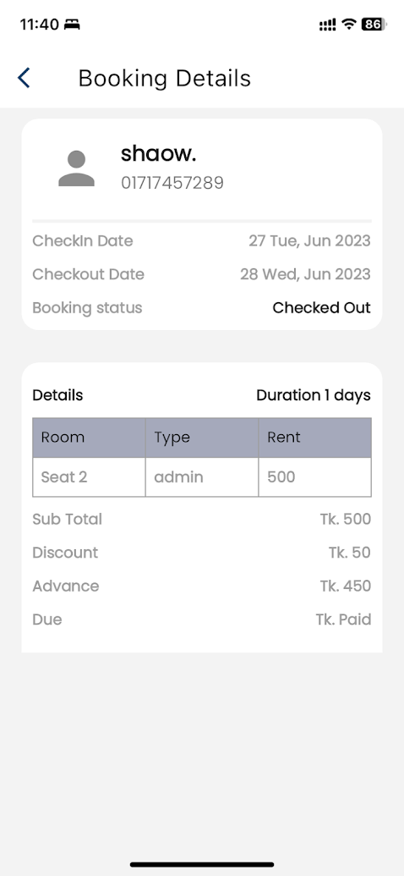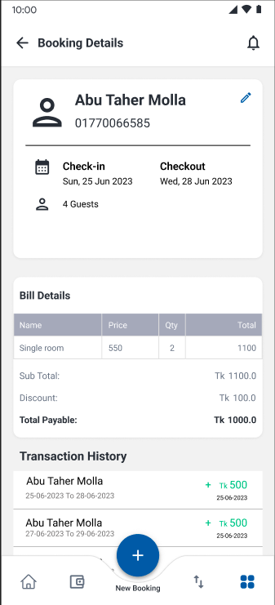

## 3. Payment Page

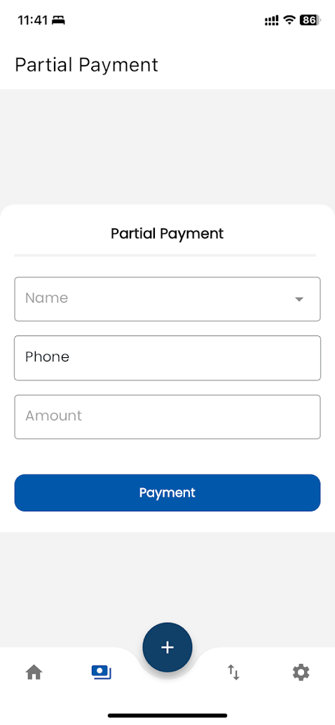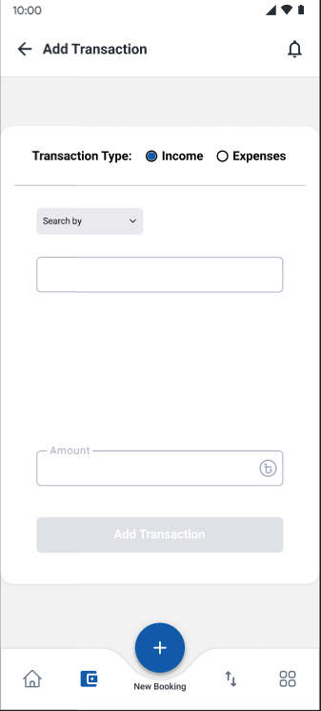

# New Features

### Update the transaction history page. Add a date range picker on the dialog. Add another transaction filer with incoming and outgoing

1. Show the starting balance and ending balance top on the transaction list
2. Add transactions based on income and expense as well as update the UI following figma design
3. Update the check-in checkout logo or icons
4. Each transaction should connect with that transaction booking
5. Modify the home page and connect amounts to the transaction page.
6. We need to design the customer support page
7. Show the transactions under the booking details
8. Show the transactions under the booking details
9. Add Room property active or inactive

**Figma link:** https://www.figma.com/file/prOcIutvMqQCQ3GmbLmEy4/Hotel-booking?type=design&node-id=0%3A1&mode=design&t=YdvxwKTggHZdc5Zm-1

We need to work with the following area.

**Image**:

# Bugs

1. Improve the booking details page. Data is getting a bit slow
2. If have any transaction against any room that room will not be deleted. We need to add this validation

.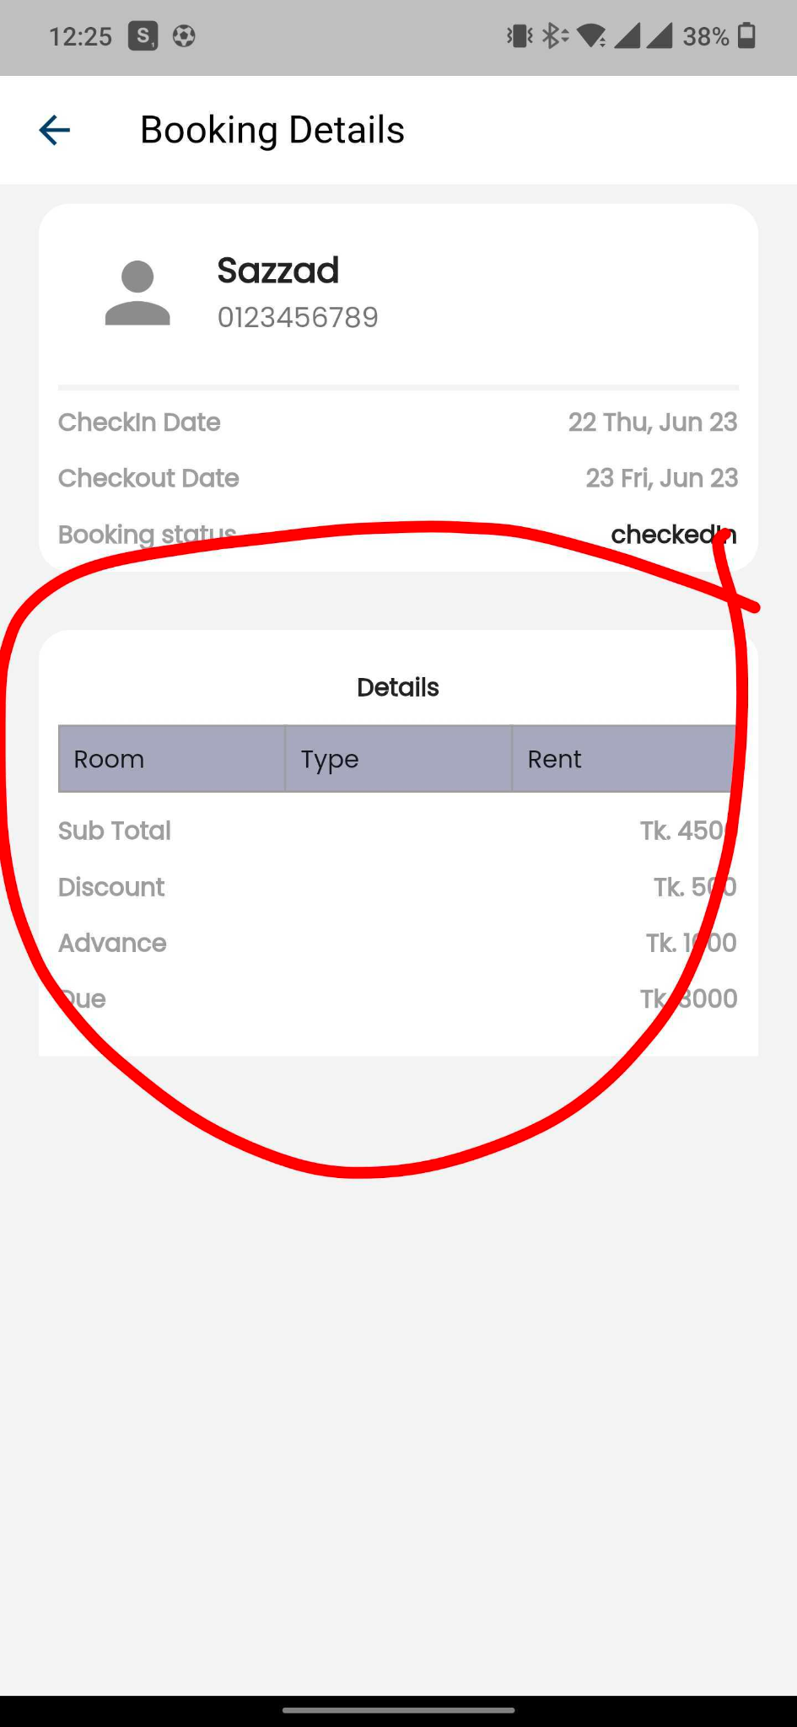

**Important app information**

1. Repo link of booking dei app: <https://github.com/nifty-apps/hotel-management-app>  
2. Repo link of booking dei backend: <https://github.com/nifty-apps/hotel-management-backend>  
3. <https://play.google.com/store/apps/details?id=com.bookingdei>

# 